**City of Sinj**

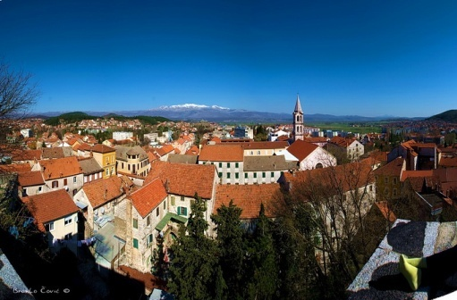

Sinj is a small city 30 km north of Split. Like the rest of Dalmatia, it has had a very turbulent history.  In August 1715 the Turks attempted to retake the Sinj fortress.  Although outnumbered, the inhabitants of Sinj defeated the Turks after a week-long battle. The defendents were convinced that the presence of the painting of Our Lady help them to thwart their more powerful adversaries. The Feast of the Assumption (Velika Gospa; August 15) is, therefore, especially significant for the residents of Sinj and many other believers from all over the country.

**If you want to participate in the Mass, see the castle fortress and the rest of the rich cultural heritage of this beautiful city you can apply for this trip. ???**